**535/3**

**PHYSICS**

**PRACTICAL**

**PAPER 3**

$$2\frac{1}{4}HOURS$$

**RESOURCEFULMOCK EXAMINATIONS 2017**

**UGANDA CERTIFICATE OF EDUCATION**

**PHYSICS PRACTICAL**

**Paper 3**

**2 hours 15 minutes**

**INSTRUCTIONS TO CANDIDATES:**

* Answer question 1 and one other question.
* You will not be allowed to start working with the apparatus for the first 15 minutes.
* Marks are given mainly for a clear record of the observations actually made. Wherever possible, candidates should put their observations in a suitable table drawn in advance.
* An account of the method of carrying out the experiment is not required.
* Graph papers are provided.
* Mathematical tables and non programmable scientific calculators may be used.

1. In this experiment, you will determine the relationship between the length of the pendulum and the intercept values.
2. Tie a piece of thread to the pendulum bob provided
3. Place the free end of the thread between two pieces of wood and clamp as shown in the figure.

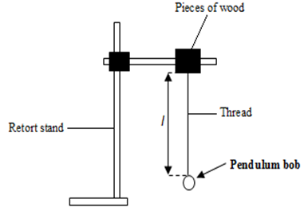

***Figure 1***

1. Adjust the length $l$ of the pendulum to 100.0cm
2. Displace the pendulum through a small angle and release it to oscillate in a vertical plane.
3. Measure and record the time for 20 oscillations.
4. Calculate the period $T_{1}$
5. Adjust the length $l$ to 80.0cm
6. Displace the bob through a small angle and release it to oscillate.
7. Measure and record the time for 20 oscillations and calculate the period $T_{2}$
8. Repeat the procedures (g) to (i) for $l=70.0,60.0,50.0, 40.0 and 30.0.$
9. Record your results in a suitable table including values of $T^{2}=T_{1}^{2}-T_{2}^{2}$
10. Plot a graph of $T^{2 }againstl .$
11. Read and record the intercepts $C_{1}$ on $T^{2}-axis$ and $C_{2}$ on the $l-axis$.
12. In this experiment, you will determine the focal length***, f,*** of the converging lens **L**. provided.

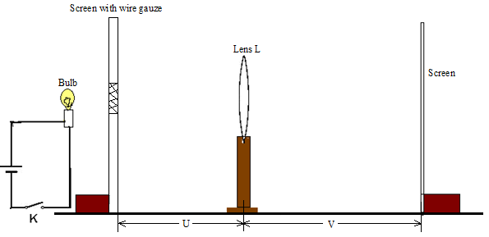

***Figure 2***

1. Connect the bulb, the dry cells and the switch, K*,* in series.
2. Arrange the bulb, the lens and the screen as shown in the figure above.
3. Adjust the distance***, u,*** between the wire gauze and the lens *L* to 70cm.
4. Close switch *K.*
5. Adjust the position of the screen to obtain a sharp image of the cross wires on it.
6. Measure and record the distance, v***,*** between the screen and the lens.
7. Open the switch.
8. Repeat procedures *(c)* to *(g)* for values of ***u*** = 60, 50, 40, 30, and 20cm.
9. Enter your results in a suitable table including values of  .
10. Plot a graph of  against *u.*
11. Read and record the intercept, *C* on the ***u*** – axis.
12. In this experiment, you will determine the internal resistance, r, of the dry cell provided.

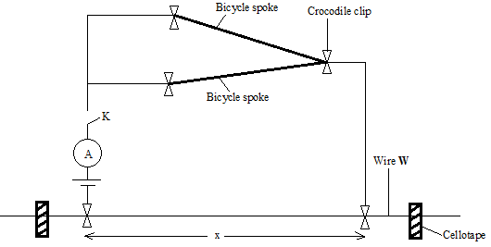

***Figure 3***

1. Fix the resistance wire, W, provided firmly on the table using cello tape.
2. Connect the circuit as shown in the figure 3 above.
3. Adjust the length $x$ of the resistance wire to 0.100m.
4. Read and record the ammeter reading $I$.
5. Repeat procedure (c) and (d) for values of $x=0.200, 0.300, 0.400, 0.500 and 0.600m$.
6. Tabulate your results including values of $\frac{1}{I}$.
7. Plot a graph of $\frac{1}{I}$ against $x$.
8. Find the slope S of the graph.
9. Read and record the intercept C on the $\frac{1}{I}-axis.$
10. Calculate the internal resistance $r$ of the cell from the expression $r=\left[4.42\frac{C}{S}-0.2\right]$.

**END**